**Naive Bayes algorithm**

**Naive Bayes** is a classification algorithm that works based on the Bayes theorem. Before explaining about Naive Bayes, first, we should discuss Bayes Theorem. Bayes theorem is used to find the probability of a hypothesis with given evidence.

In this, using Bayes theorem we can find the probability of A, given that B occurred. A is the hypothesis and B is the evidence.

P(B|A) is the probability of B given that A is True.

P(A) and P(B) is the independent probabilities of A and B.

###### 

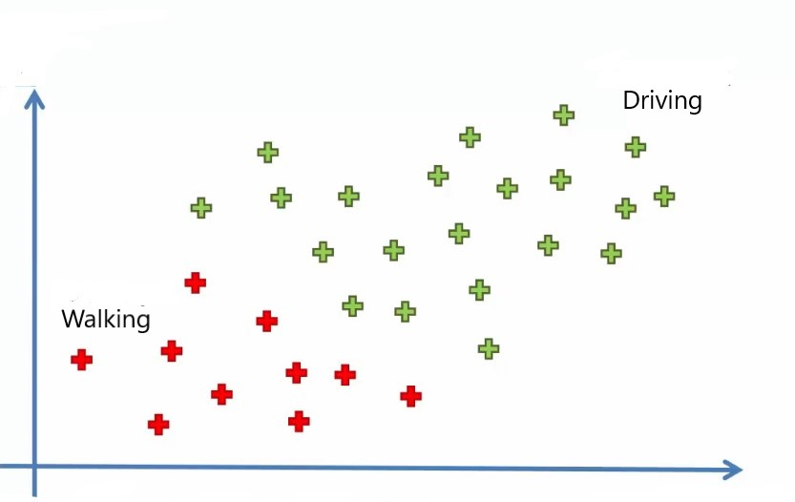

## The concept behind the algorithm

Let’s understand the concept of the Naive Bayes Theorem through an example. We are taking a dataset of employees in a company, our aim is to create a model to find whether a person is going to the office by driving or walking using salary and age of the person.

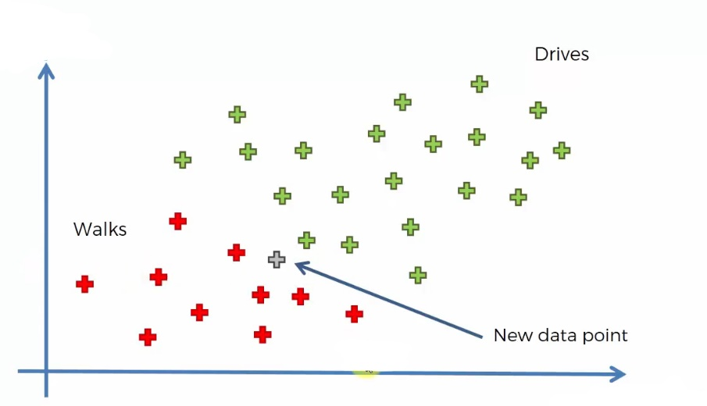

In the above, we can see 30 data points in which red points belong to those who are walking and green belongs to those who are driving. Now let’s add a new data point into it. Our aim is to find the category that the new point belongs to.

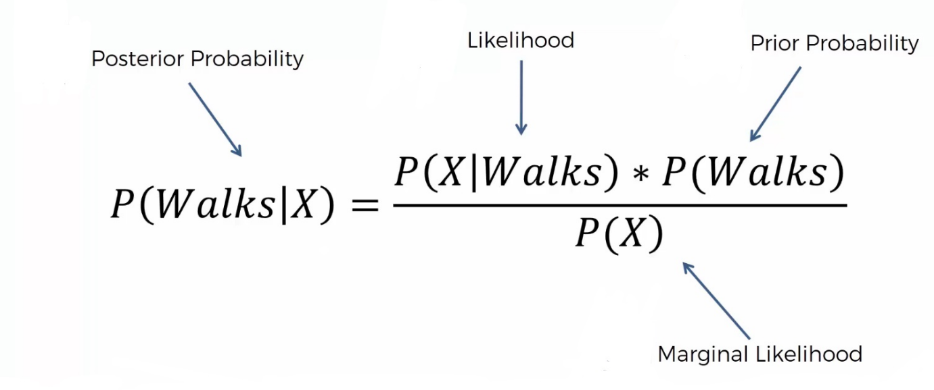

Note that we are taken age on the X-axis and Salary on the Y-axis. We are using the Naive Bayes algorithm to find the category of the new data point. For this, we have to find the posterior probability of walking and driving for this data point. After comparing, the point belongs to the category having a higher probability.

The posterior probability of walking for the new data point is :



also for the driving is :

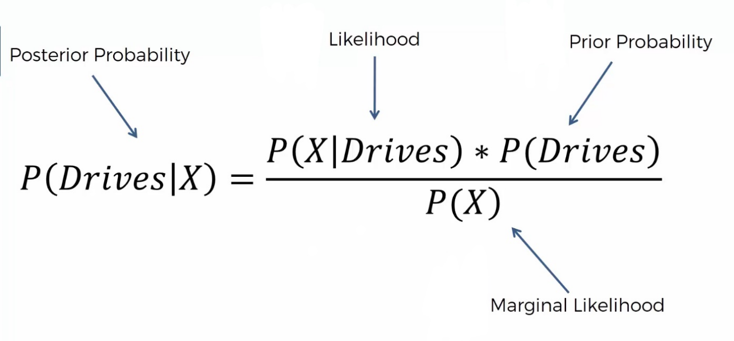

## Steps involved in Naive Bayes algorithm

**Step 1**: We have to find all the probabilities required for the Bayes theorem for the calculation of posterior probability

P(Walks) is simply the probability of those who walk among all

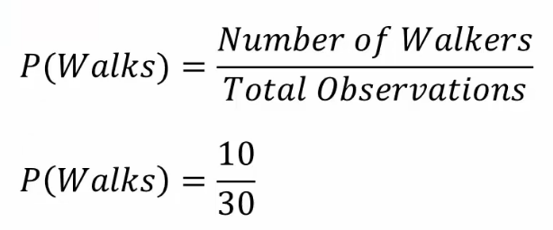

In order to find the marginal likelihood, P(X), we have to consider a circle around the new data point of any radii including some red and green points.

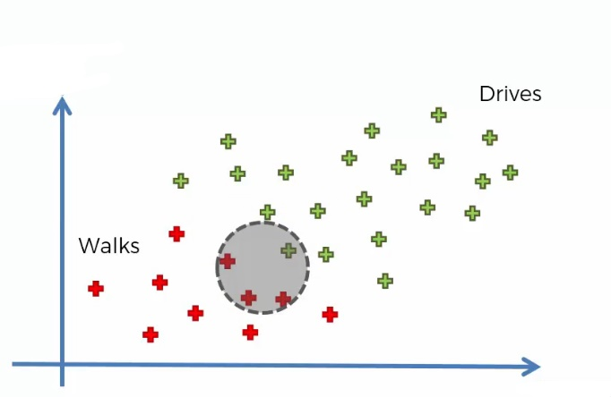

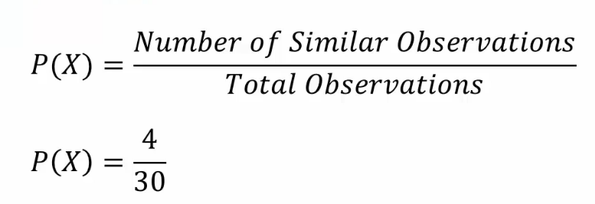

P(X|Walks) can be found by :

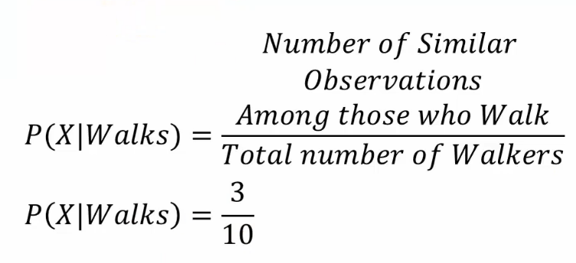

Now we can find the posterior probability using the Bayes theorem,

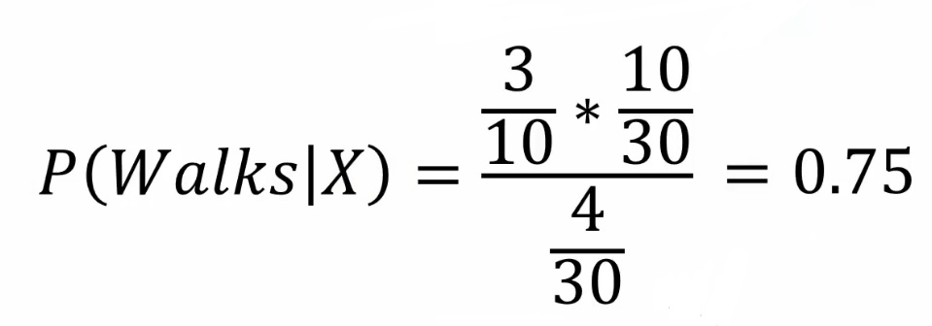

**Step 2**: Similarly we can find the posterior probability of Driving, and it is 0.25

**Step 3**: Compare both posterior probabilities. When comparing the posterior probability, we can find that P(walks|X) has greater values and the new point belongs to the walking category.